Cointegration and ECM: AUDUSD and EURGBP
Method 27 / Engle-Granger on log closes / one-lag ECM / Alpari D1 full available history

Study setup
Logical pair: PX=AUDUSD , PY=EURGBP
Broker symbols: AUDUSD_i , EURGBP_i
Snapshot: 2026-11-03_majors_alpari_D1
Timeframe: D1
Matched window: 1999-01-06 to 2026-11-02 (UTC bar dates)
Matched level count n: 7198
Dropped unfinished last bar dated 2026-11-03 UTC after a tick-volume check against the prior complete day.
ECM lags of deltas: 1
Complete matched rows (Excel): AUDUSD-EURGBP_Coint_D1.xlsx
Complete matched rows (HTML table): AUDUSD-EURGBP_Coint_D1_data.html

Method carried forward
Engle-Granger cointegration works on log price levels, not returns. For each unordered pair, PX is the left leg and PY the right leg. Step one: OLS ln(PY) = alpha + beta * ln(PX) + e. Step two: statsmodels Engle-Granger coint test on (ln(PY), ln(PX)). Error-correction: delta ln(PY)_t = c + kappa * e_{t-1} + lagged delta ln(PY) and delta ln(PX) (one lag each) + u_t. Headline is the Engle-Granger p-value (lower = stronger evidence of a stationary spread) with kappa and beta reported alongside. Same-sample Pearson r of log returns is a side check only. beta is not an automatic lot-size hedge. This is not a trading signal.

Results (headline)
alpha: -0.151328
beta: 0.321120
Engle-Granger t: -1.633619
Engle-Granger p: 0.706493
5% critical value: -3.336979
ECM kappa: -0.000729
kappa t-stat: -1.4602
ECM R^2: 0.001349
spread std: 0.114967
Pearson r (returns): 0.038173

Conclusion
Engle-Granger for PY=EURGBP on PX=AUDUSD: beta=0.3211, alpha=-0.1513, coint_t=-1.6336, p=0.7065 (5% crit=-3.3370). ECM kappa=-0.0007 (t=-1.46). Pearson r of returns = 0.0382. beta is not a lot-size hedge. Not a trading signal.

Charts
Daily closes

Engle-Granger residual spread
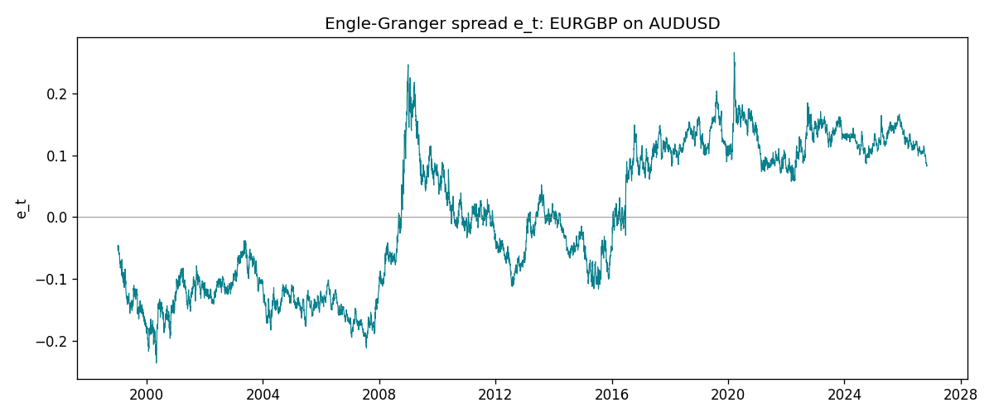
Daily log returns
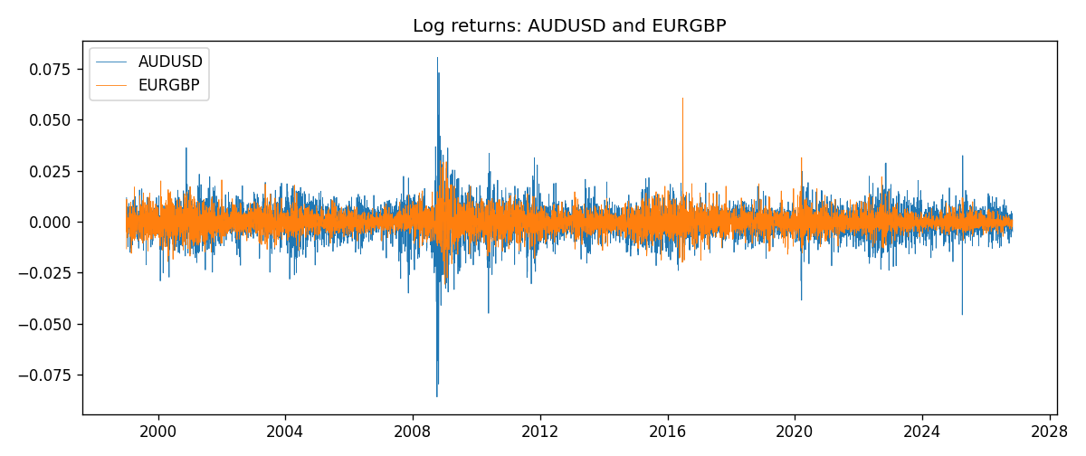

Data report
Matched rows are in the sibling Excel workbook named AUDUSD-EURGBP_Coint_D1.xlsx. Embedding all rows as a Word table is impractical; this file holds column summaries and the first and last 15 matched rows.
Column summaries
column | count | mean | std | min | 25% | 50% | 75% | max
AUDUSD_open | 7198 | 0.75202191 | 0.13526259 | 0.4785 | 0.6611175 | 0.731685 | 0.8091425 | 1.10284
EURGBP_open | 7198 | 0.78667202 | 0.09675257 | 0.5734 | 0.687325 | 0.83369 | 0.8651775 | 0.9769
AUDUSD_high | 7198 | 0.7560731 | 0.13582215 | 0.4878 | 0.6648025 | 0.7351 | 0.8153975 | 1.10795
EURGBP_high | 7198 | 0.7897492 | 0.09712763 | 0.5789 | 0.6894 | 0.836595 | 0.86804 | 0.9799
AUDUSD_low | 7198 | 0.74796393 | 0.1345766 | 0.4775 | 0.6578225 | 0.727775 | 0.804275 | 1.0975
EURGBP_low | 7198 | 0.7839722 | 0.09657024 | 0.5682 | 0.6853 | 0.831475 | 0.8627775 | 0.9661
AUDUSD_close | 7198 | 0.75206897 | 0.13524509 | 0.4786 | 0.661255 | 0.7318 | 0.8092725 | 1.10169
EURGBP_close | 7198 | 0.78671595 | 0.09675201 | 0.5735 | 0.687525 | 0.83375 | 0.865285 | 0.977
AUDUSD_tick_volume | 7198 | 77378.184 | 138156.24 | 109 | 5445.75 | 43349.5 | 71356.75 | 1234623
EURGBP_tick_volume | 7198 | 86961.088 | 145396.59 | 332 | 6520.25 | 44270 | 81329 | 1424684
AUDUSD_spread | 7198 | 30.809114 | 16.88495 | 0 | 13 | 30 | 50 | 50
EURGBP_spread | 7198 | 21.389692 | 19.14164 | 0 | 4 | 13 | 50 | 50
AUDUSD_real_volume | 7198 | 5.2442754e+09 | 1.2540657e+11 | 0 | 0 | 0 | 0 | 3.811512e+12
EURGBP_real_volume | 7198 | 2.7809077e+10 | 1.3507993e+11 | 0 | 0 | 0 | 0 | 3.5726265e+12
AUDUSD_log_price | 7198 | -0.30067912 | 0.1768783 | -0.7368901 | -0.41361574 | -0.31224803 | -0.21161959 | 0.09684536
EURGBP_log_price | 7198 | -0.24788236 | 0.12823275 | -0.55599734 | -0.37465709 | -0.18182168 | -0.14469635 | -0.02326863
AUDUSD_log_return | 7198 | 2.054e-05 | 0.00754782 | -0.08602525 | -0.00386556 | 0.00027727 | 0.00415374 | 0.0806166
EURGBP_log_return | 7198 | 2.199e-05 | 0.00487197 | -0.03067367 | -0.00262256 | -0.00010006 | 0.00256155 | 0.06075387
spread_e | 7198 | -0 | 0.11496734 | -0.23653918 | -0.11078916 | -0.00215307 | 0.1116297 | 0.26659171
ecm_fitted | 7197 | 2.384e-05 | 0.00017885 | -0.00170158 | -8.628e-05 | 1.952e-05 | 0.0001282 | 0.00174202
First 15 matched rows (selected columns)
time | AUDUSD_log_price | EURGBP_log_price | spread_e | AUDUSD_log_return | EURGBP_log_return
1999-01-06 | -0.46378302 | -0.35396434 | -0.053706012 | 0.011836351 | -0.013303338
1999-01-07 | -0.45491799 | -0.34291293 | -0.045501349 | 0.0088650256 | 0.011051402
1999-01-08 | -0.45460283 | -0.3478568 | -0.050546416 | 0.00031515916 | -0.004943862
1999-01-11 | -0.44738145 | -0.34913203 | -0.054140587 | 0.0072213815 | -0.0012752393
1999-01-12 | -0.4522423 | -0.345735 | -0.049182639 | -0.0048608485 | 0.0033970309
1999-01-13 | -0.46013251 | -0.34531119 | -0.046225114 | -0.0078902098 | 0.00042381861
1999-01-14 | -0.46282943 | -0.34729054 | -0.047338439 | -0.002696916 | -0.0019793588
1999-01-15 | -0.45570632 | -0.35496213 | -0.057297392 | 0.007123101 | -0.0076715819
1999-01-18 | -0.4547604 | -0.35424932 | -0.056888339 | 0.00094592471 | 0.00071280921
1999-01-19 | -0.44753788 | -0.35567544 | -0.060633762 | 0.0072225153 | -0.0014261269
1999-01-20 | -0.4462871 | -0.35367943 | -0.059039404 | 0.0012507819 | 0.0019960086
1999-01-21 | -0.44550616 | -0.35439184 | -0.060002585 | 0.00078094498 | -0.00071240297
1999-01-22 | -0.4577589 | -0.35610368 | -0.057779821 | -0.012252745 | -0.0017118406
1999-01-25 | -0.46171805 | -0.36154392 | -0.061948701 | -0.0039591468 | -0.0054402425
1999-01-26 | -0.46124212 | -0.3621183 | -0.062675913 | 0.00047592608 | -0.00057438255
Last 15 matched rows (selected columns)
time | AUDUSD_log_price | EURGBP_log_price | spread_e | AUDUSD_log_return | EURGBP_log_return
2026-10-13 | -0.35923536 | -0.16891582 | 0.097770137 | 0.0035007712 | 0.00020130374
2026-10-14 | -0.36075468 | -0.16779163 | 0.099382209 | -0.0015193215 | 0.0011241873
2026-10-15 | -0.36829939 | -0.1686672 | 0.10092939 | -0.0075447063 | -0.00087557391
2026-10-16 | -0.36490875 | -0.17070529 | 0.097802505 | 0.0033906408 | -0.0020380844
2026-10-19 | -0.35982275 | -0.1712748 | 0.095599778 | 0.0050859986 | -0.00056950988
2026-10-20 | -0.35636071 | -0.17486542 | 0.090897421 | 0.0034620426 | -0.0035906254
2026-10-21 | -0.35275407 | -0.17627189 | 0.088332786 | 0.0036066384 | -0.00140647
2026-10-22 | -0.35402133 | -0.17814629 | 0.086865335 | -0.0012672558 | -0.0018743924
2026-10-23 | -0.35164476 | -0.17732208 | 0.086926382 | 0.0023765656 | 0.00082421033
2026-10-26 | -0.35484804 | -0.17719074 | 0.088086354 | -0.0032032829 | 0.00013133309
2026-10-27 | -0.35318105 | -0.17918648 | 0.085555317 | 0.0016669876 | -0.0019957343
2026-10-28 | -0.3490895 | -0.1785168 | 0.084911108 | 0.0040915541 | 0.00066967224
2026-10-29 | -0.35318105 | -0.17968902 | 0.085052768 | -0.0040915541 | -0.0011722209
2026-10-30 | -0.35217082 | -0.18210958 | 0.082307806 | 0.0010102376 | -0.0024205543
2026-11-02 | -0.35708932 | -0.18121017 | 0.08478664 | -0.0049184984 | 0.00089940465

